www.therapha.com

**홈페이지 목적:** 간단한 정보 제공 =>전화를 유도하기 위함.

Upper left

Rapha Acupuncture & Herbal Clinic

Logo

Upper Right / 425-874-3888

Make an appointment

**윗쪽 메뉴: About Us / Rates and Insurance / Contact**

**좌측 메뉴: Conditions we treat / Our treatment / FAQ / New patient info**

Bottom

Content Copyright © 2010 Jungmin Ahn, EAMP All rights reserved.   
425-874-3888 / 32020 1st Ave S, STE 106, Federal Way, WA 98003

**1. Home Button: Rapha Logo**

Up:

1. About Us: Our Clinic images

2. Rates and Insurance

3. Contact

Left:

1. Conditions we treat

2. Our treatment

3. Q&A

4. New Patient info

**Left below**

Testimonial => Yelp

**Home** (Experiencing Optimal Health)

Welcome to the Rapha Acupuncture & Herbal Clinic

WE ARE HERE TO HELP YOU

사진 돌아가기

라파 한의원 정면 사진   
리셉션 사진 (환자분 intake 하는 것)  
진단실 사진 (임원장님 진맥)  
치료실 사진 (안정민 침 놓는거)

Read or Write a review of Rapha Acupuncture & Herbal Clinic

Yelp: <http://www.yelp.com/biz/rapha-acupuncture-and-herbal-federal-way>

Google:   
  
  
Yahoo   
https://local.yahoo.com/info-93611138-rapha-acupuncture-herbal-federal-way

Mapquest:  
http://www.mapquest.com/us/washington/business-federal-way/rapha-acupuncture-herbal-275769338

**1. About us**

Jungmin Ahn is an East Asian Medicine Practitioner, formerly known as Licensed Acupuncturist. Originally from South Korea, He has learned and practiced medical knowledge and natural healing methods under various institutes, doctors and masters. Now he would like to share his knowledge and experience with you who want optimal health and life.

[ahnemp@gmail.com](mailto:ahnemp@gmail.com)

**2. Insurance & rates**

Rapha Acupuncture & Herbal Clinic accepts most insurance plans including auto & travel insurance.

In-Network Provider

* Aetna
* Cigna
* Lifewise
* Premera
* United Healthcare
* Auto Insurances
* Traveling insurances

Out-Network Provider

* Regence PPO
* Group Health
* First Choice

Acupuncture treatment is eligible for HSA, HRA for Flexible medical expenses.

If you have little or no acupuncture insurance coverage or no insurance at all, we will be happy to work with you and discuss payment arrangements. Please call our clinic for more information.

**3. Contact**

지도: Direction

***Rapha 광고판 사진 /*32020 Professional Building 사진**

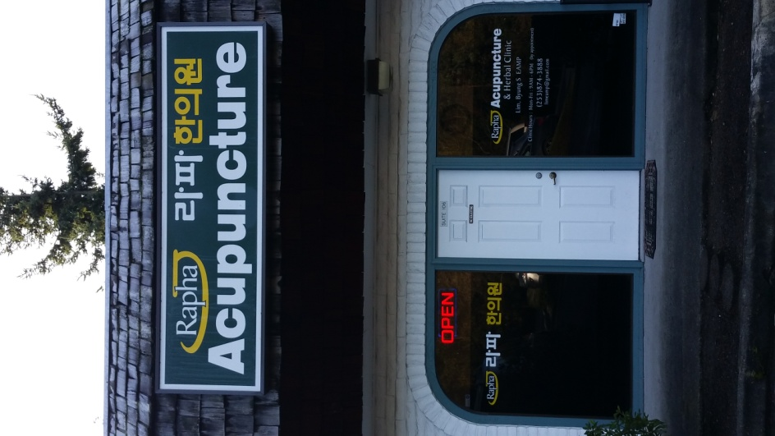

32020 1st Ave S, STE 106, Federal Way, WA 98003

E-mail: good@therapha.com  
Phone: 253-874-3888   
Fax: 253-883-3543

|  |  |
| --- | --- |
| Clinic hours  Monday: 9 AM ~ 6 PM  Tuesday: 9 AM ~ 6 PM  Wednesday: 9 AM ~ 6PM  Thursday: 9 AM ~ 6PM  Friday: 9 AM ~ 6PM  By appointment only | - Directly e-mail to ahneamp@gmail.com  BOX style  Name:  E-mail address:  Message: |

**1. Conditions we treat** (Experiencing Extraordinary Specialty)

**Pain Management**

Auto Injury Back pain   
Neck pain  
Headache   
Carpal Tunnel Syndrome   
Premenstrual syndrome   
Sports Injury   
Post operative pain

**Sinusitis & Rhinitis**

**Insomnia**

**Digestive disorders**

**Infertility**

**2. Our treatment** (Safe & Natural Healing)

**Various styles of Acupuncture:** Thin needles are used to regulate Qi flow(vital energy), internal organ functions, and energy pathways called “meridian” We offers various styles of Acupuncture such as Korean & Chinese & Japanese, anatomical, hand, ear, intra-dermal.

**Electro-Acupuncture:** a form of acupuncture where a small electric current is passed between pairs of acupuncture needles.

**Herbal therapy:**Asian herbal therapy uses formula from natural sources like plants, animals and minerals. It has been used earlier than acupuncture. Each herb has different taste, color, energetic temperature, Qi direction that goes to different meridians, organs. Herbal formula uses various single herbs for the synergetic effect.

**Asian Manual Therapy:** Asian manipulative therapy to promotes Qi and Blood circulation and unblock energy pathway.

**Infra-Ray Heat:** infrared emissions increases microcirculation and loosens fascia to accelerate the natural healing processes of the body. Infrared heat goes deeper into tissue to stimulate local Ki and Blood circulation.

**Wellness Regimen**

**Acupressure:** To reduce pain and stimulate circulation, Natural pain-killer  
  
**Meridian stretching:**  To unblock and stimulate the flow of stagnated meridians  
  
**Meditation:** To rest your brain and calm mind

**Deep Breathing:** To Increase vitality and oxygen intake and promote parasympathetic system

**Hydrotherapy:** To increase Qi and blood circulation

**Emotional Freedom Technique:** an emotional version of acupuncture without needle that manipulate the body’s energy field by tapping on acupuncture points, and clear disturbed an energy field form negative emotions.

**Asian Therapeutic Nutrition:**Every food has different energy like herbs. Asian Nutrition address imbalance of Yin & Yang and Five elements in our body and mind. In order to reach balance, we prescribe the food that you need to eat and encourage you not to eat the food that causes imbalance. Through individualized food plan along with food awareness and healthy eating habit, we help you reach balance and harmony within.

**3. Q&A**

**Does it hurt?**Needles are thickness of a human hair. Most people relieve needle anxiety when the first acupuncture needle is inserted.

**What is acupuncture?**: Thin needles are used to regulate Ki flow(vital energy), internal organ functions, and energy pathways called “meridian”

**How does it work?**Ki(vital energy) flows in the body along specific energy pathways which are each associated with a particular physiological system and internal organ. We stimulate acupuncture points to regulate the balance of internal organ and energy pathways.

**What does acupuncture feel like?**After insertion you may feel a sensation of warmth, heaviness, tingling, or dull aching but there should be no pain. Acupuncture needles are very fine, about the size of a thick hair.

**What could someone expect?**Improve Qi & blood circulation and endorphin level to relieve pain.  
Harmonize yin and yang, thus enhancing the immune system & restoring function of self healing.  
Improve metabolism and balance endocrine system   
Activate parasympathetic nerve system to relax and rejuvenate

**Is acupuncture safe?**In the hands of a Licensed Acupuncturist, your safety is assured. The needles used are sterilized, and disposable, just for one time use.

**How many treatments do I need?**This depends upon the duration, severity, and nature of the complaint as well as patient’s response to the treatment. We usually recommend 4~6 treatments for one month period to evaluate your therapeutic response. Most people experience some degree of immediate relief from acupuncture treatment. Please consult with a licensed acupuncturist.

**What is East Asian Medicine?**

East Asian Medicine is a comprehensive medical system with a long history of preventing and treating a wide range of illness from musculoskeletal problems to emotional issues.

One of the reasons for the effectiveness of EAM is its ability to address a patient’s individual health concerns. The unique diagnostic system employed by a EAM practitioner allows the practitioner to assess the myriad of physical and mental factors contributing to the patient’s condition and develop a treatment plan according to various factors of Asian Medicine Diagnosis Theory. This emphasis on holism, totality and individualization is one of the key features of EAM and one of its most prominent differences from conventional biomedicine.

The strength of EAM is its ability to correct the underlying cause of disease not just the presentation of symptoms. While bothersome symptoms will be addressed at each acupuncture appointment, the ultimate effect of EAM will be to stimulate the body’s self-correcting mechanisms and restore healthy functioning. Because every patient will respond to EAM at different speeds it is important to speak to your practitioner about the frequency and number of treatments you should receive.

**Benefit of Acupuncture**

1. Improve Qi and blood flow; reduce inflammation

2. Promote endorphin release to relieve pain; Improve ROM

3. Harmonize yin and yang, thus enhancing the immune system & restoring function of self healing.

4. Improve metabolism and balance endocrine system

5. Activate parasympathetic nerve system to relax and rejuvenate

**4. New Patient info**

**First appointment preparation   
   
Preparation   
Please wear comfortable clothing that can roll up to above knee and elbow.  
Please come with a light stomach, not full stomach.   
Please do not brush your tongue and drink coffee.   
Please bring your insurance card.**

**Paperwork (10 min)  
Write the demographic information and sign on consent forms   
  
Intake (15 min)   
Go over the first visit history intake and Asian Medicine Diagnostic Questionnaire   
Your chief complaint intake and necessary physical exam**

**Diagnosis (10 min)  
Explain your disease or discomfort from Asian Medicine perspective.**

**Treatment (15 min)  
Treatment with various therapeutic methods depending on your needs**

**Please click on Treatment methods for more information.**